BIRLA INSTITUTE OF TECHNOLOGY AND SCIENCE, PILANI
BIO F215, BIOPHYSICS

SECOND SEMESTER 2015 – 2016
MID-SEMESTER EXAM (CLOSED BOOK)
Full marks: 60 DATE: 18.03.16 DURATION: 90 Mins.
- Answer to the point
- Irrelevant and verbose answer may attract penalty
- Steps in each calculation carry marks

1. a) Explain the following fact with proper diagram (whenever necessary) [5X3=15]
i) Gly and Pro is more abundant with the loop/turn region of a protein structure
ii) (0,0) Phi (φ) and Psi (ψ) combination of a amino acid is generally not observed in protein structure.
iii) In protein, mutation of Trp to any other amino acid shows more drastic effect than Val to any other amino acid though both Trp and Val are hydrophobic in nature
iv) First derivative methods are more popular in biomolecular energy minimization.
v) In a stable protein structure more than one secondary structural unit are found.
b) How the elastic properties of a biopolymer is defined by persistence length? Is this length temperature dependent? Justify your arguments. [2+3]

2. a) Following figure depict interaction of a substrate with an enzyme ‘X’. The potential interaction sites of enzyme are indicated by 1-5. If a favorable interaction is likely take place at each site between the chemical group on the substrate and the closest side chain of an amino acid on ‘X’, give the name of amino acid side chains at position 1 to 5 and strongest direct intermolecular interaction. Justify your answer. [5]
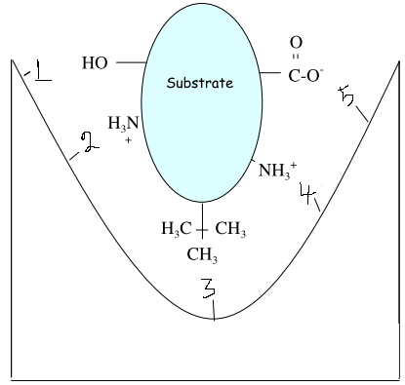

X

b) Consider the following amino acid sequence: AELQAKSAIAHELQAKSAIAHA
When treated with ATP in the presence of a kinase, the serine side-chains are phosphorylated as follows:
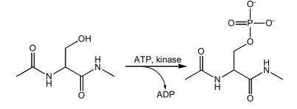

At pH 5 the phosphorylated sequence is an α-helix. Use a helical wheel diagram to indicate the stabilizing interactions of the phosphorylated sequence. [5]

3.a) The hydrogen bond between two water molecules in isolation is about ten times stronger energetically than a van der Waals contact between two xenon atoms, yet water molecules dimerize in the gas phase only 30% more frequently than xenon atoms. Why? [3]
b) Ion exchange chromatography separates amino acids and peptides based on charge. Rank the following peptides based on how strongly they bind to an anion exchanger at pH 4. (refer to pK_{a} values given). i) Ala-Ser-Lys-Leu-Asn-Cys-Tyr ii) Arg-Val-Asp-Met-Glu-Phe-Gln [3]
c) The unfolding of the α-helix of a polypeptide to a randomly coiled conformation is accompanied by a large decrease in a property called its specific rotation, a measure of a solution’s capacity to rotate plane-polarized light. When the pH is raised to 7 from 3, there is a large decrease in the specific rotation of the solution of Polyglutamate, a polypeptide made up of only L-Glu residues. Similarly, when the pH of polylysine (L-Lys residues) is lowered to 7 from 10, the specific rotation also decreases, as shown by the following graph.
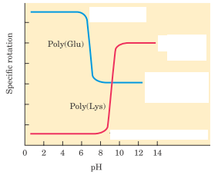

What is the explanation for the effect of the pH changes on the conformations of poly(Glu) and poly(Lys)? Why does the transition occur over such a narrow range of pH? [4]

4. a) Derive the working equation of molecular dynamics simulation from basic assumptions. [3]
b) Explain typical van der Waal potential curve. Explain why for computational convenience, van der Waals energies and forces can be computed for pairs of atoms only within some “cutoff radius”. [3+2]
c) Explain the fundamental concept of derivative minimization methods. [2]

5. a) Draw atomistic detail of a typical γ-turn. [3]
b) Why do we observe variation in hydrophobicity scale of amino acids? [3]
c) Following table shows the residues and corresponding phi (φ) and psi (ψ) angles of a stable poly-peptide structure. Critically review the values and identify alpha helical region and turn region. Justify your answer. [4]

 | N1 | L2 | Y3 | I4 | Q5 | W6 | L7 | K8 | D9 | G10 | G11 | P12 | S13 | S14 | G15 | R16 | K17 | S18
φ | - | -44 | -66 | -65 | -65 | -73 | -65 | -60 | -78 | 111 | 55 | -58 | -82 | -124 | 68 | -144 | -70 | -69
ψ | -56 | -51 | -31 | -46 | -30 | -43 | -43 | -26 | -9 | 8 | -124 | -29 | -19 | 13 | 25 | 131 | 160 | 146

**************************************************************************

